

**Faculty of Engineering & Technology Electrical & Computer Engineering Department**

**Communication Lab - ENEE4113**

**Experiment 2: Double-side and Single-side Band Modulation**

**Prelab #2**

**Student Name**: Maha Maher Mali

**Student ID**: 1200746

**Instructor**: Dr. Ashraf Al_Rimawi

**Teacher Assistant**: Eng. Mohammed Battat

**Section**: 4

**Date**: 3-8-2023

Contents

Theoretical Prelab 5

Double-Sideband Suppressed Carrier (DSB-SC) Modulation 5

Mathematical Representation of DSB-SC modulation 5

Generation of DSB-SC signal 5

Demodulation of DSB-SC 6

Single-Sideband Modulation (SSB) 6

Mathematical Representation of SSB Modulation 6

Generation of SSB signal 7

Demodulation of SSB 7

Software Prelab (Simulink MATLAB) 8

Message signal 8

Plot Message signal in Time Domine 8

Plot Message signal in Frequency Domine 9

9

Carrier signal 9

Plot Carrier signal in Time Domine 10

Plot Carrier signal in Frequency Domine 10

DSB-SC Modulation and Demodulation 11

DSB-SC Modulation 11

DSB-SC Demodulation 12

SSB-SC Modulation and Demodulation 14

SSB-SC Modulation Method 1(Lower Side) 14

SSB-SC Demodulation 15

SSB-SC Modulation and Demodulation 17

SSB-SC Modulation Method 2(Lower Side) 17

SSB-SC Demodulation 19

References 21

**Table of Figures**

Figure 1: Generation of DSB-SC signal 5

Figure 2: Demodulation of DSB-SC 6

Figure 3: Generation of SSB signal 7

Figure 4: Demodulation of SSB 7

Figure 5: Message signal in Time Domine 8

Figure 6: Message signal in Frequency Domine 9

Figure 7: Carrier signal in Time Domine 10

Figure 8: Carrier signal in Frequency Domine 10

Figure 9: DSB-SC Modulation 11

Figure 10: Modulated Signal in Time Domain 11

Figure 11: Modulated Signal in Frequency Domain 12

Figure 12: DSB-SC Demodulation 12

Figure 13: Demodulated Signal in Time Domain 13

Figure 14: Demodulated Signal in Frequency Domain 13

Figure 15: SSB-SC Modulation Method 1(Lower Side) 14

Figure 16: Modulated Signal in Time Domain 14

Figure 17: Modulated Signal in Frequency Domain 15

Figure 18: SSB-SC Demodulation 15

Figure 19: Demodulated Signal in Time Domain 16

Figure 20: Demodulated Signal in Frequency Domain 16

Figure 21: SSB-SC Modulation Method 2(Lower Side) 17

Figure 22: Modulated Signal in Time Domain 17

Figure 23: Modulated Signal in Frequency Domain 18

Figure 24: SSB-SC Demodulation 19

Figure 25: Demodulated Signal in Time Domain 19

Figure 26: Demodulated Signal in Frequency Domain 20

# Theoretical Prelab

## Double-Sideband Suppressed Carrier (DSB-SC) Modulation

DSB-SC is an amplitude modulated wave transmission scheme in which only sidebands are transmitted and the carrier is not transmitted as it gets suppressed. DSB-SC is an acronym for Double Sideband Suppressed Carrier.[1]

The carrier does not contain any information and its transmission results in loss of power. Thus, only sidebands are transmitted that contains information. This results in saving of power used in transmission.[1]

### Mathematical Representation of DSB-SC modulation

Where:

* s(t): is the modulated signal.
* m(t): is the message signal.

### Generation of DSB-SC signal

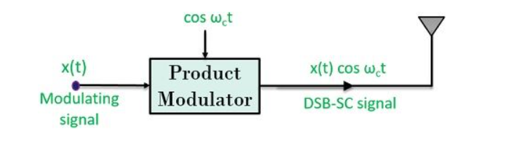

Figure 1: Generation of DSB-SC signal

Here, by observing the above figure, we can say that a product modulator generates a DSB-SC signal. The signal is obtained by the multiplication of baseband signal x(t) with carrier signal cos ωct.

### Demodulation of DSB-SC

For DSBSC, Coherent Demodulation is done by multiplying the DSB-SC signal with the carrier signal (with the same phase as in the modulation process) just like the modulation process. This resultant signal is then passed through a low pass filter to produce a scaled version of the original message signal.[2]

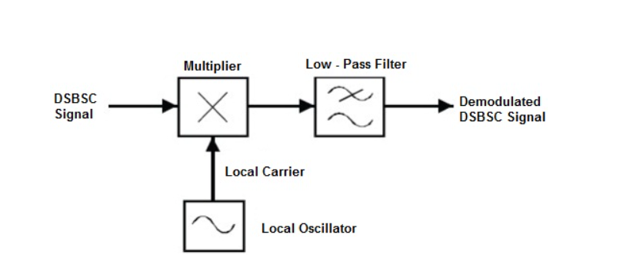

Figure : Demodulation of DSB-SC

_____________________________________________________________________________________

## Single-Sideband Modulation (SSB)

Single side band (SSB) is an amplitude modulation technique in which only one sideband (upper or lower) is transmitted, along with the carrier wave or a suppressed carrier. This method results in a much more efficient use of the available bandwidth than AM or DSB-SC, as only half the bandwidth is required for transmission. SSB modulation can be achieved using a variety of techniques, including frequency-domain filtering or phase-shift modulation.

### Mathematical Representation of SSB Modulation

#### Upper sideband (USB)

#### Lower sideband (LSB)

### Generation of SSB signal

SSB modulation can be generated by filtering the undesired side band of a DSBSC signal and retaining the desired one using a bandpass filter with bandwidth equal that of the message signal (not twice its bandwidth) and a center frequency equal to the center frequency of the desired side band (not the carrier).

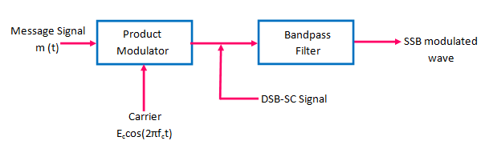

Figure : Generation of SSB signal

### Demodulation of SSB

The sideband at the positive and negative frequencies merge (recombine) at zero frequency when the SSB signal is multiplied by the carrier.

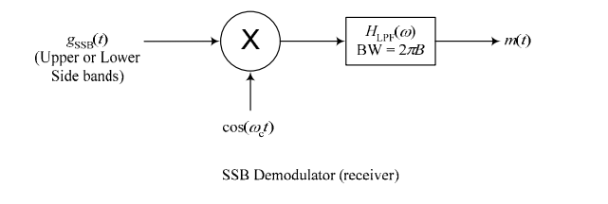

Figure 4: Demodulation of SSB

If the SSB signal includes a LARGE carrier, it can be demodulated using an envelope detector similar to that used for full AM signals.

# Software Prelab (Simulink MATLAB)

## Message signal

𝑚(𝑡) = 0.85cos (2𝜋 (1000) 𝑡)

### Plot Message signal in Time Domine

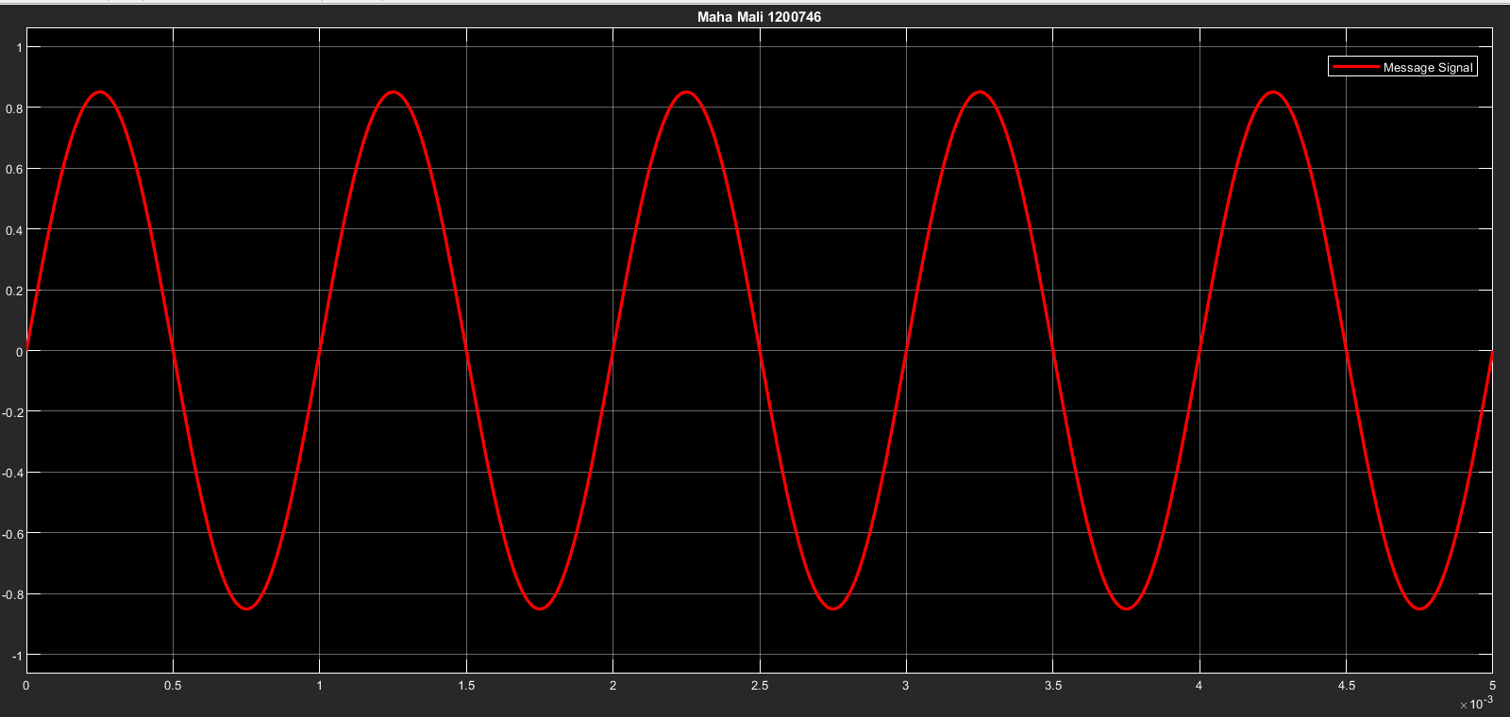

Figure 5: Message signal in Time Domine

### Plot Message signal in Frequency Domine

### 

Figure 6: Message signal in Frequency Domine

From the graph for Message signal in Frequency Domine we notice that we have two delta one at -1000,and anotheor on 1000 as we calculate in mathmatical according this eqation:

## Carrier signal

𝑐(𝑡) = 1cos(2𝜋(15𝑘) 𝑡)

### Plot Carrier signal in Time Domine

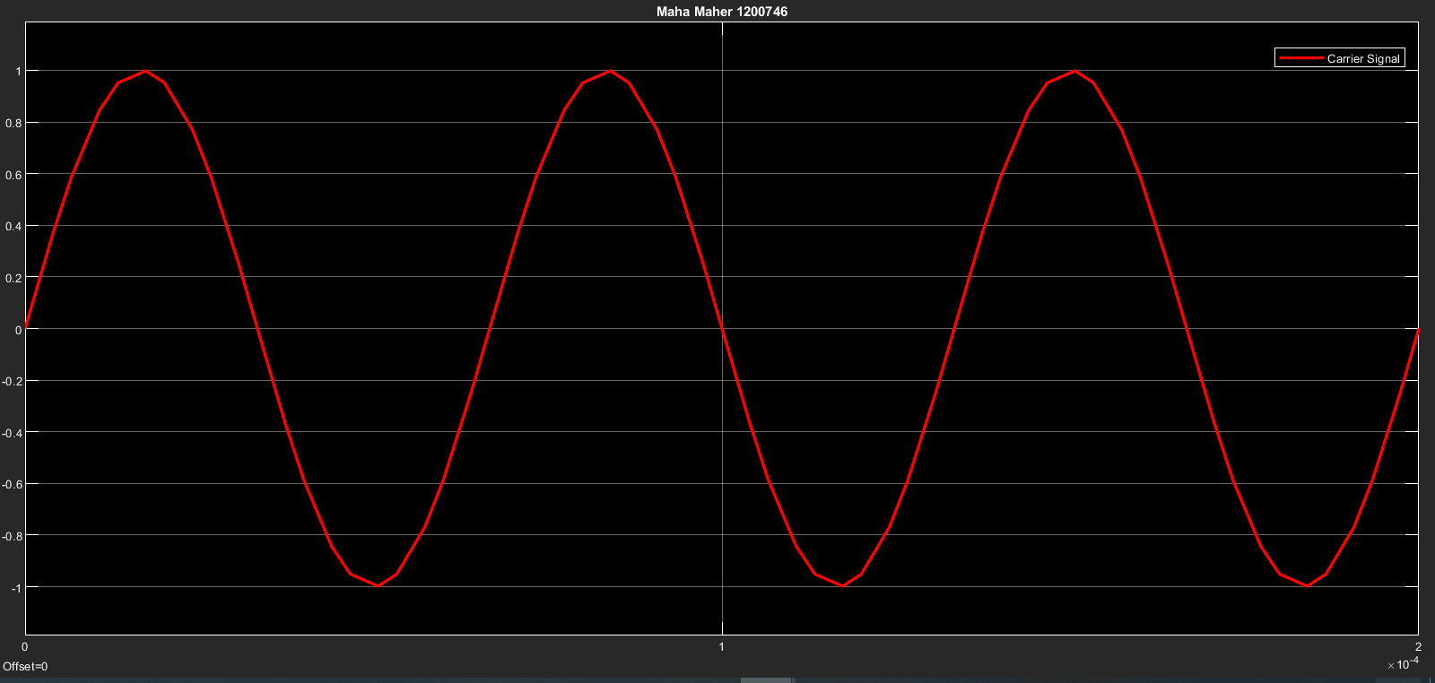

Figure 7: Carrier signal in Time Domine

### Plot Carrier signal in Frequency Domine

Figure 8: Carrier signal in Frequency Domine

From the graph for Message signal in Frequency Domine we notice that we have two delta one at -15000,and anotheor on 15000 as we calculate in mathmatical according this eqation:

## DSB-SC Modulation and Demodulation

### DSB-SC Modulation

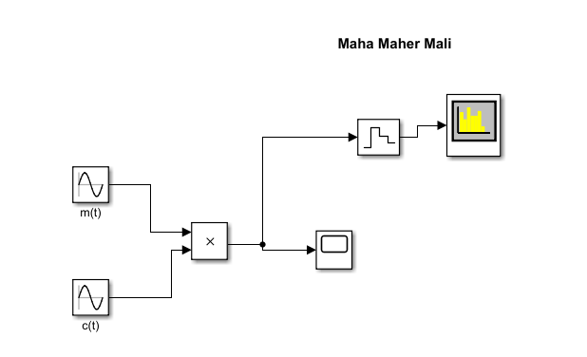

Figure 9: DSB-SC Modulation

S(t) = (0.85/2) cos (2pi (16000)) + (0.85/2) cos (2pi (14000))

#### Plot Modulated Signal in Time Domain

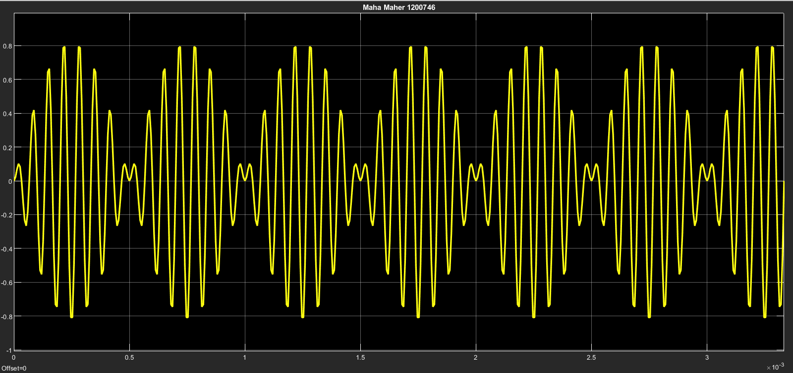

Figure 10: Modulated Signal in Time Domain

#### Plot Modulated Signal in Frequency Domain

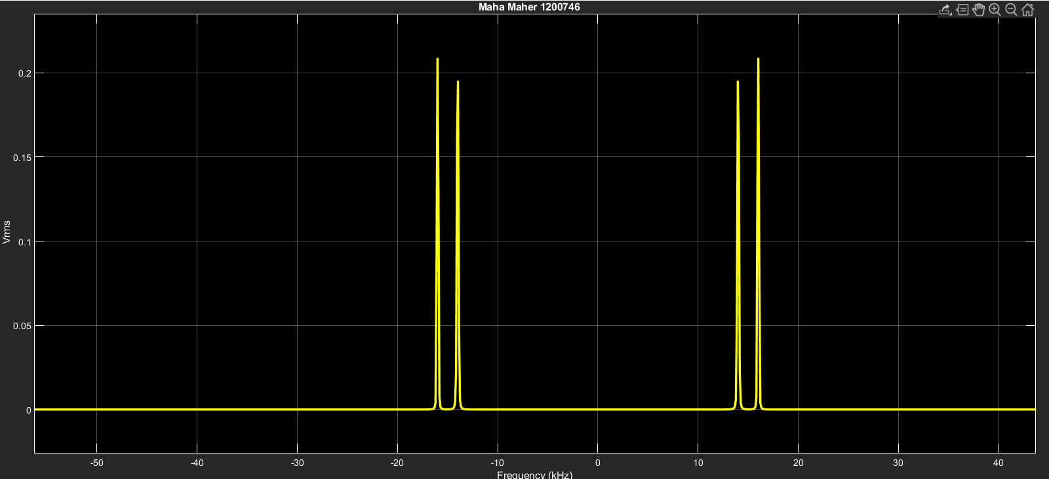

Figure 11: Modulated Signal in Frequency Domain

From this graph we notice that we have two deltas:

One at fc+fm=15000+1000=16000

And another at fc-fm=15000-1000=14000

### DSB-SC Demodulation

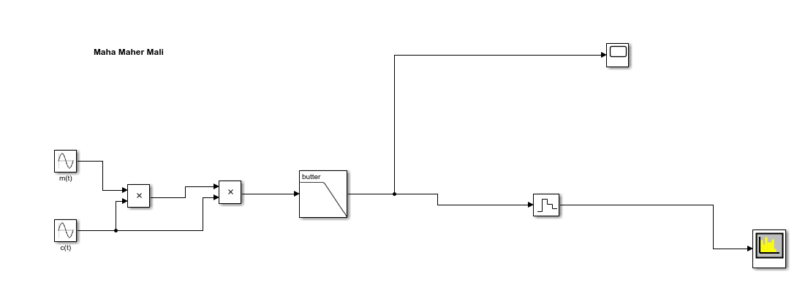

Figure 12: DSB-SC Demodulation

#### Demodulated Signal in Time Domain

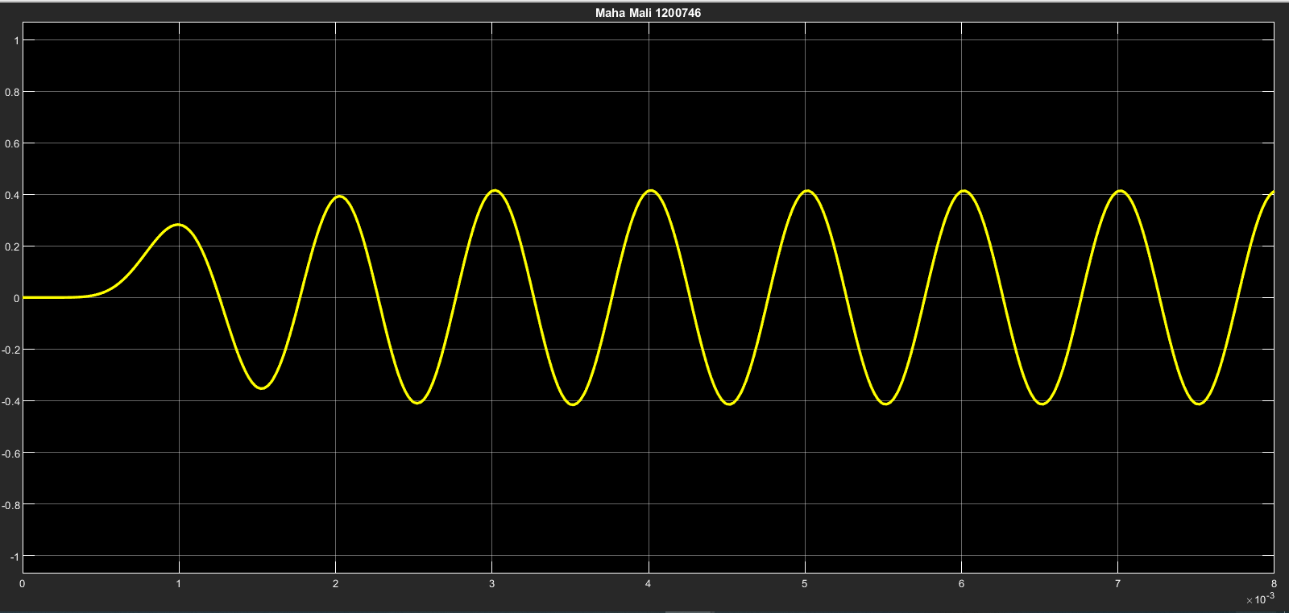

Figure 13: Demodulated Signal in Time Domain

#### Demodulated Signal in Frequency Domain

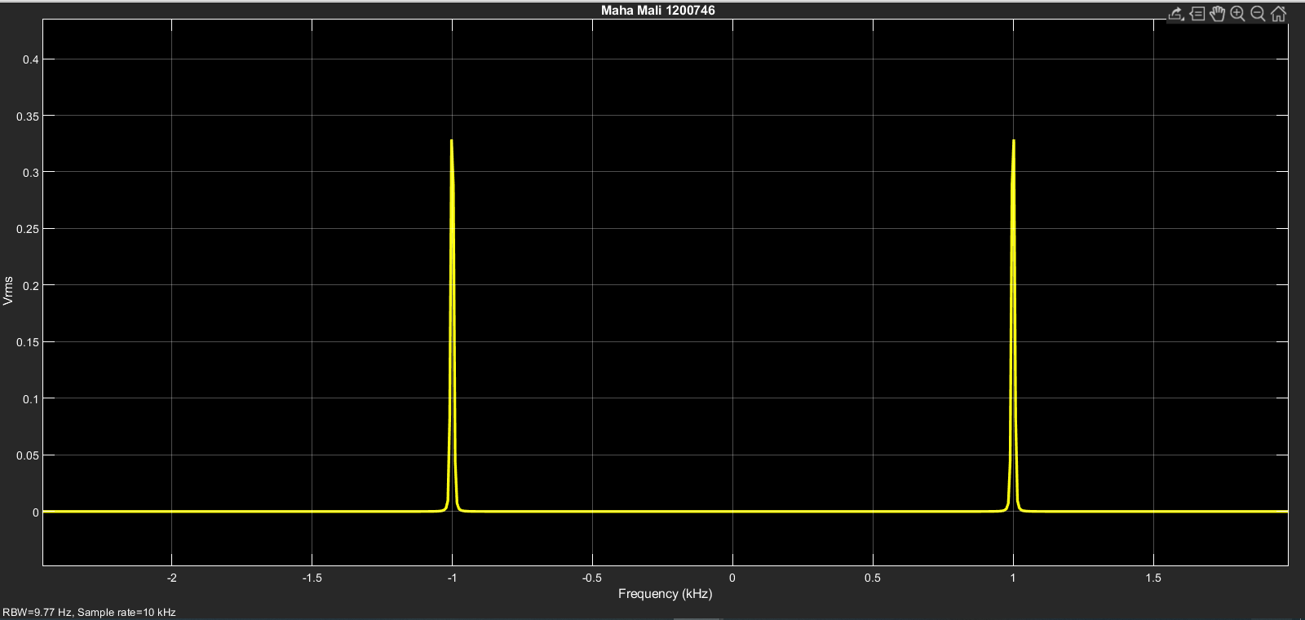

Figure 14: Demodulated Signal in Frequency Domain

From the Demodulated Signal in Frequency Domain we notice that we get the orignail meessage at freqancy 1000,and -1000.

## SSB-SC Modulation and Demodulation

### SSB-SC Modulation Method 1(Lower Side)

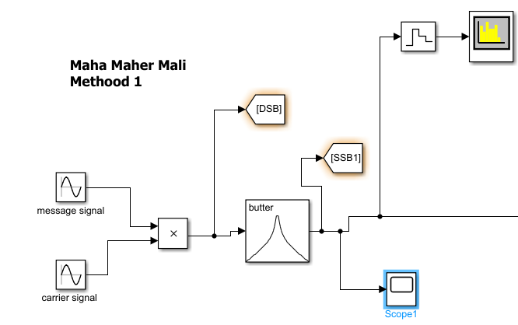

Figure 15: SSB-SC Modulation Method 1(Lower Side)

#### Modulated Signal in Time Domain

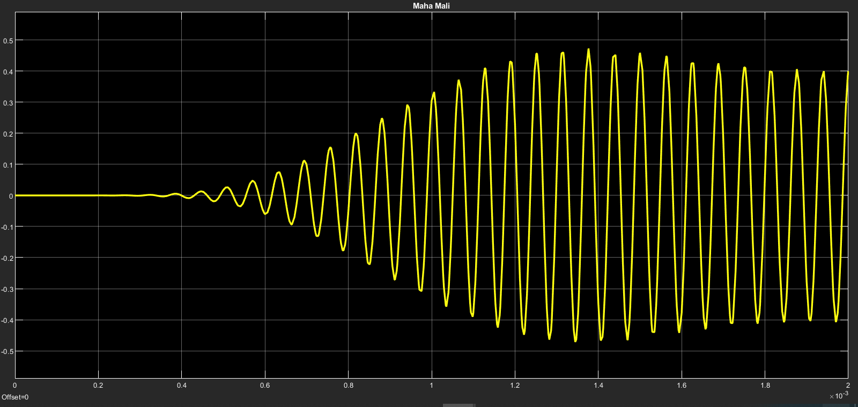

Figure : Modulated Signal in Time Domain

#### Modulated Signal in Frequency Domain

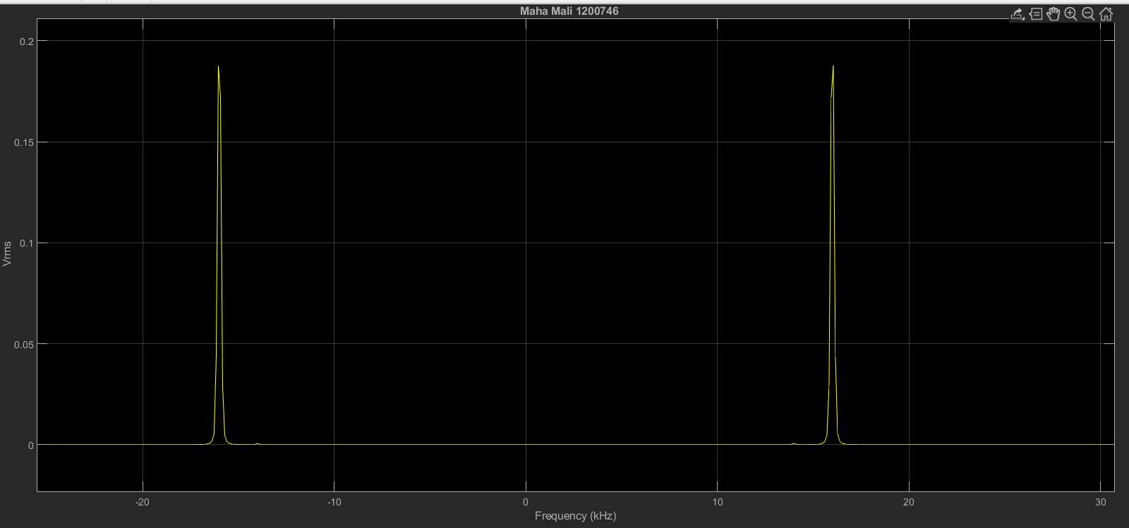

Figure : Modulated Signal in Frequency Domain

### SSB-SC Demodulation

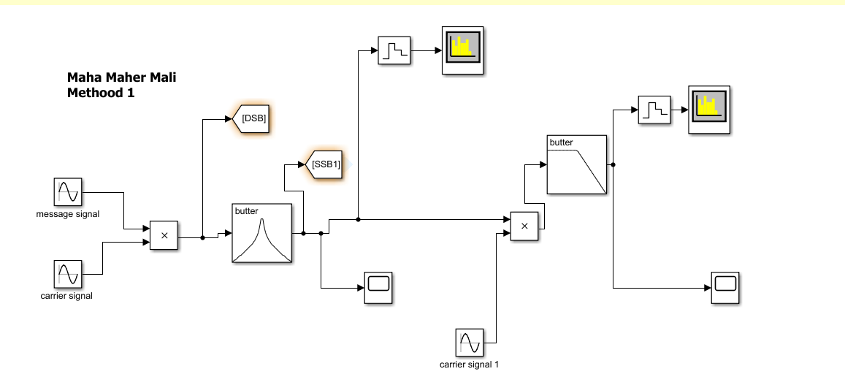

Figure : SSB-SC Demodulation

#### Demodulated Signal in Time Domain

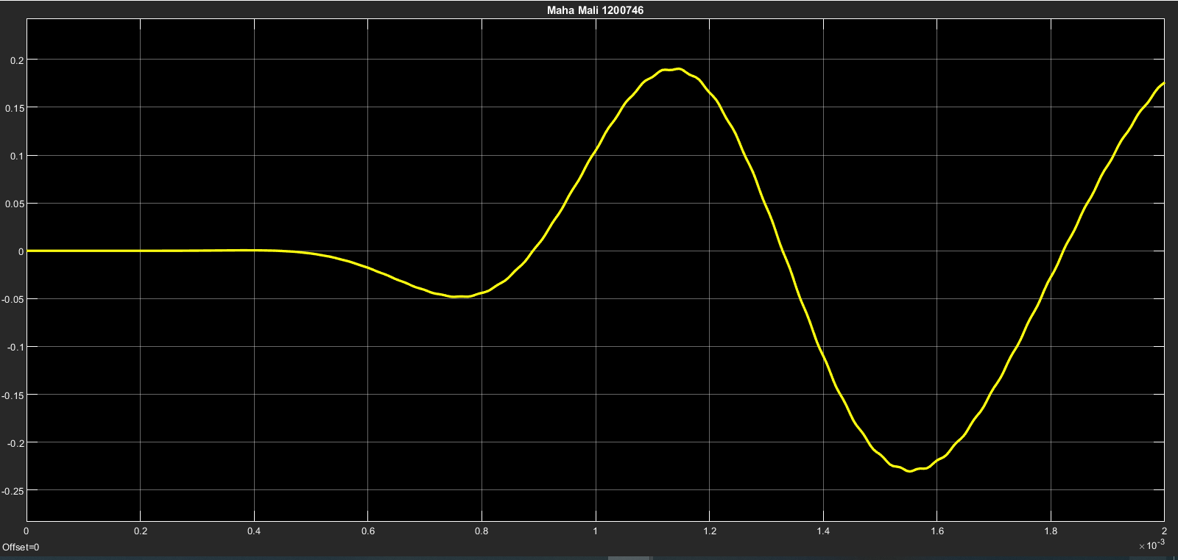

Figure : Demodulated Signal in Time Domain

#### Demodulated Signal in Frequency Domain

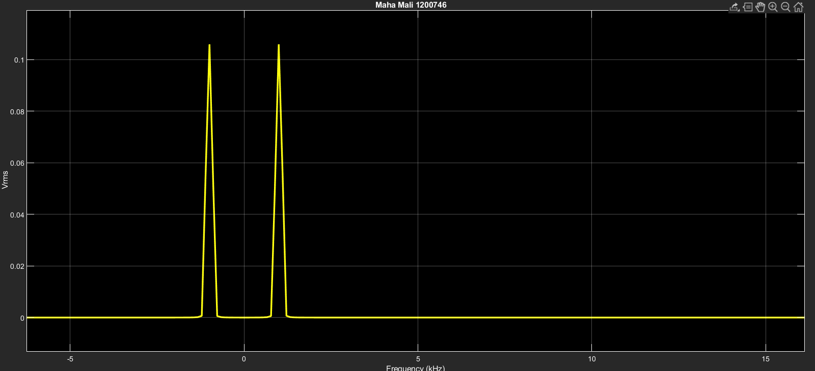

Figure : Demodulated Signal in Frequency Domain

## SSB-SC Modulation and Demodulation

### SSB-SC Modulation Method 2(Lower Side)

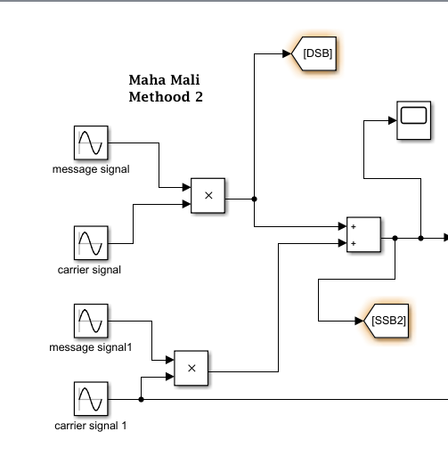

Figure 21: SSB-SC Modulation Method 2(Lower Side)

#### Modulated Signal in Time Domain

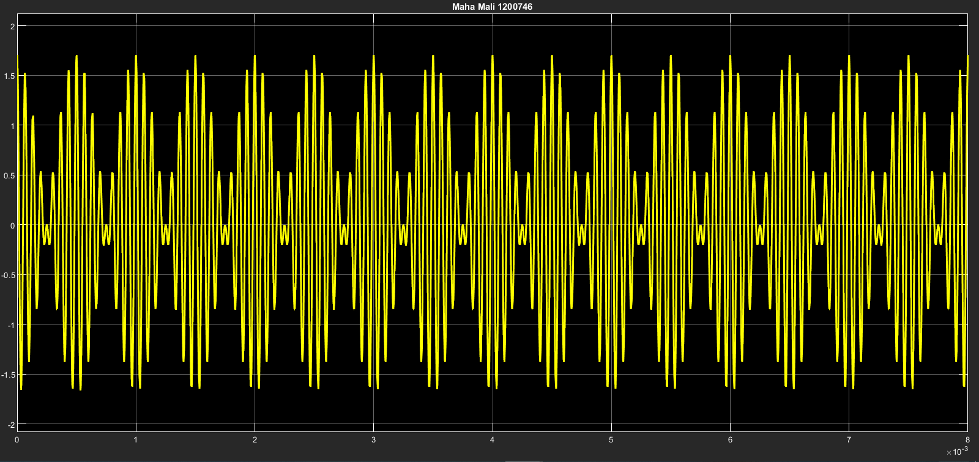

Figure : Modulated Signal in Time Domain

#### Modulated Signal in Frequency Domain

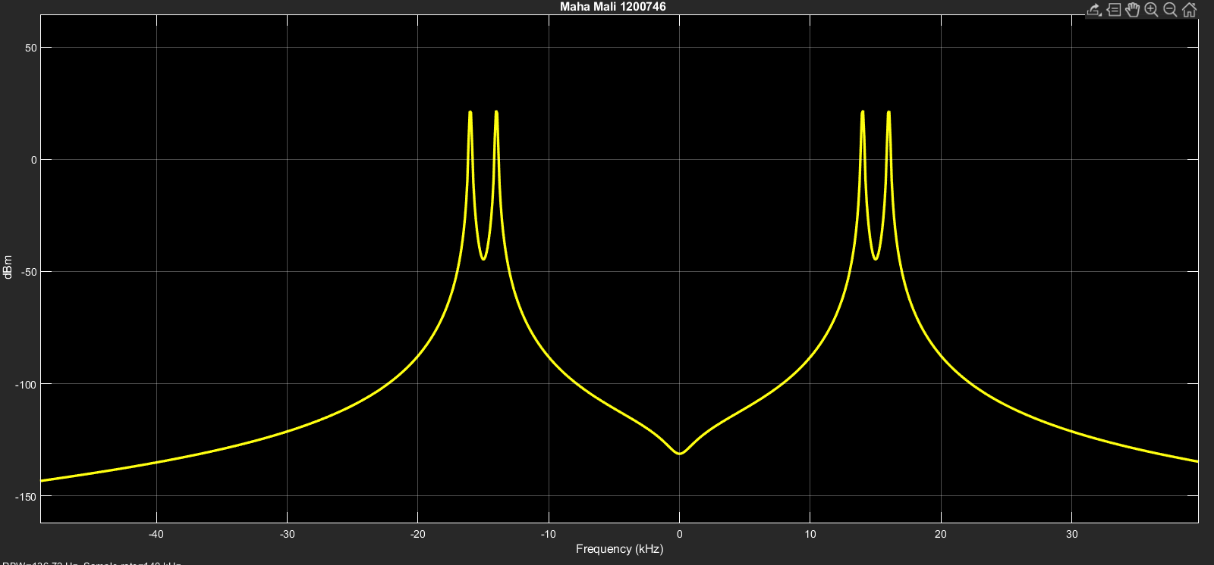

Figure : Modulated Signal in Frequency Domain

### SSB-SC Demodulation

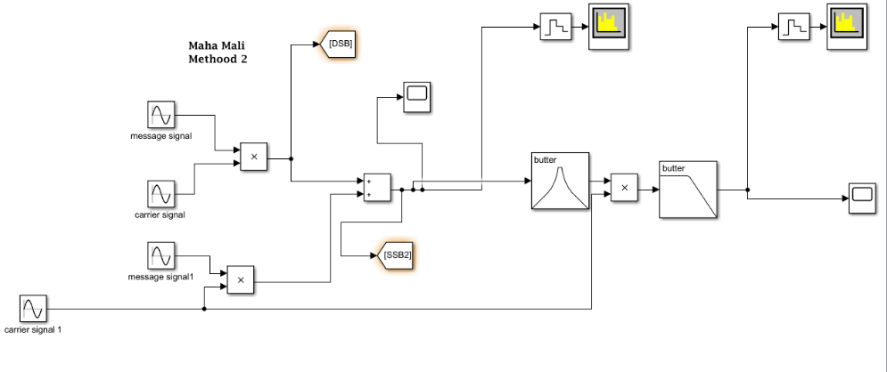

Figure 24: SSB-SC Demodulation

#### Demodulated Signal in Time Domain

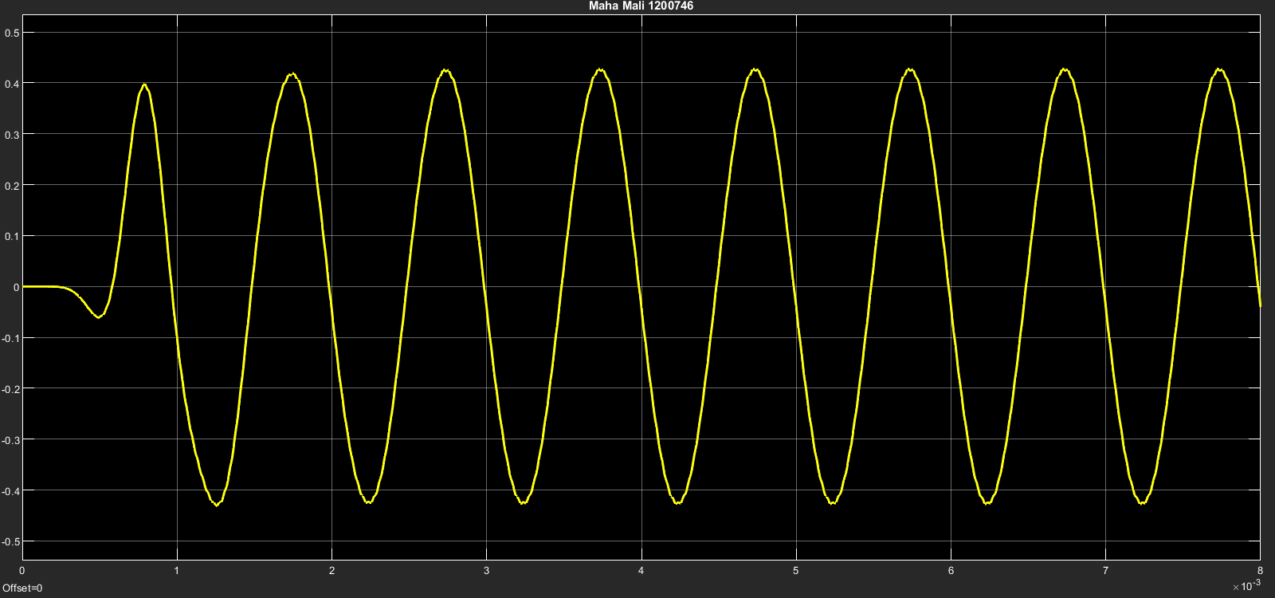

Figure 25: Demodulated Signal in Time Domain

#### Demodulated Signal in Frequency Domain

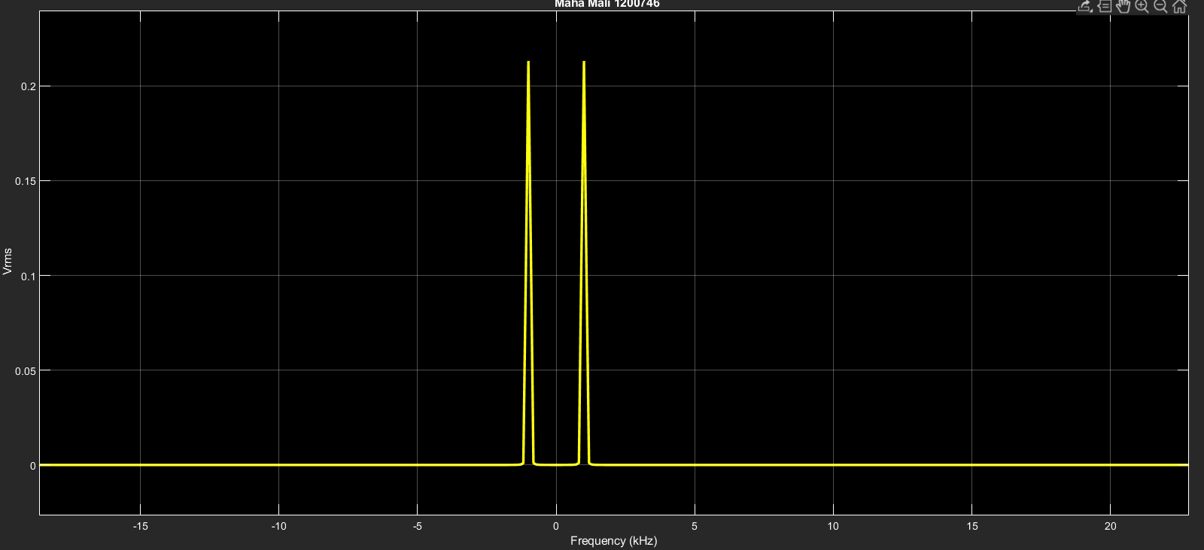

Figure 26: Demodulated Signal in Frequency Domain

# References

[1] <https://electronicscoach.com/double-sideband-suppressed-carrier-modulation.html>

[2] <https://en.wikipedia.org/wiki/Double-sideband_suppressed-carrier_transmission>